**CHSK201尺寸图**

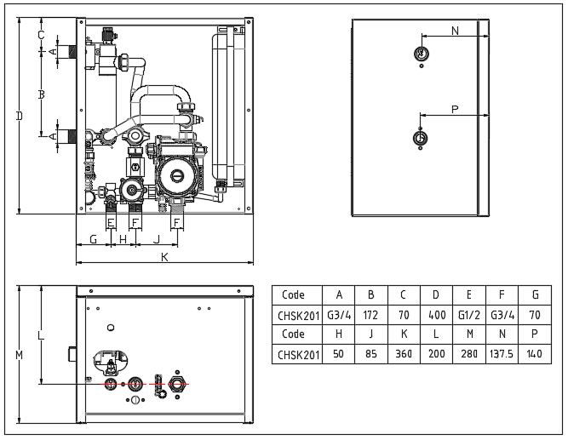

1. mm